**Student ID: 22001928**

**Student Name: Zarak Khan**

Life Expectancy Analysis (WHO)

In this Assignment I have used an open source data set from World Bank a repository. You can find this data set from the following link.

<https://data.worldbank.org/indicator/SP.DYN.LE00.IN>

The data set represents the average number of years a newborn infant is projected to live, assuming that mortality rates at the time of their birth remain constant throughout their lifespan. I performed following visualizations on the data.

# Visualization 1: Life Expectancy for Lower Average Countries

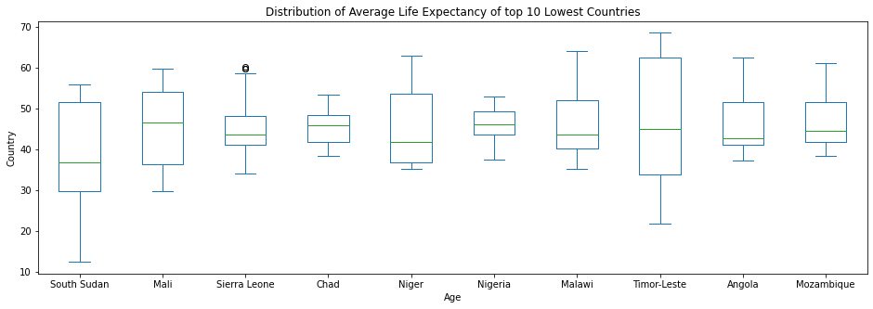

This graph is for the Countries whose average life expectancy is the lowest from 1960 to 2020 and those countries are.

South Sudan

Mali

Sierra Leone

Chad

Niger

Nigeria

Malawi

Timor-Leste

Angola

Mozambique

There life expectancy graph is showing some fluctuations like for South Sudan the life expectancy sometimes falls below 15 years. But most of the countries starts from 30 years in 1960 and now in 2020 it reached to 45 to 55 years.

# Visualization 2: Life Expectancy for Highest Average Countries

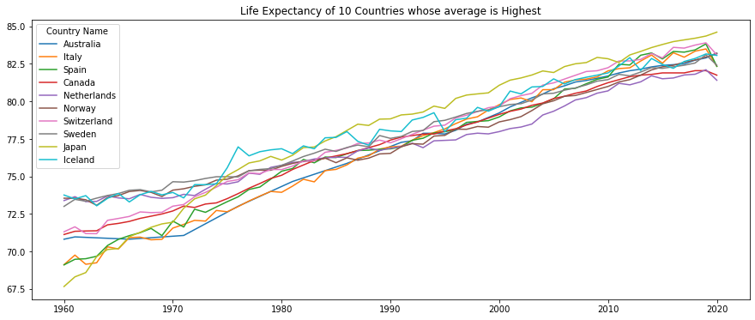

This graph is for the Countries whose average life expectancy is the highest from 1960 to 2020 and those countries are.

Australia

Italy

Spain

Canada

Netherlands

Norway

Switzerland

Sweden

Japan

Iceland

In 1960, life expectancy was around 70 years that has increased to 83 by 2020. That’s mean the living standard is increasing year by year.

# Visualization 3: Life Expectancy according to the Continents

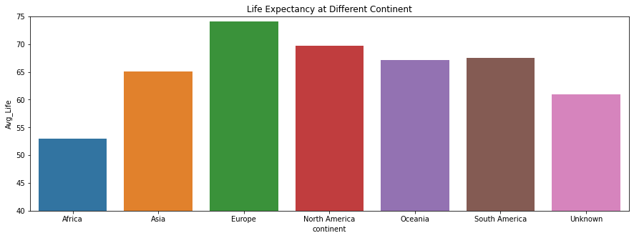

This plot is for different countries of continent’s average life expectancy from 1960 to 2020 and from this plot it can be seen that the average life expectancy in Europe is highest that is around 73 years. And the lowest life expectancy is for African countries that is around 53 years.

GitHub Repository Link:

<https://github.com/zeekokhan/7PAM2000-0105-2022-Applied-Data-Science-1-Assignment-1-Visualisation-20>